In the first Little Bird Tale, Mrs. Davis discusses the process she led her students through as they completed their continent research.

<http://www.littlebirdtales.com/tales/view/story_id/229520>

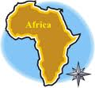

Mrs. Davis’ students learned about Africa.

<http://www.littlebirdtales.com/tales/view/story_id/224337>

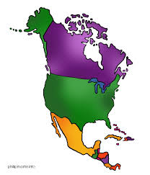

Mrs. Davis’s students learned about North America.

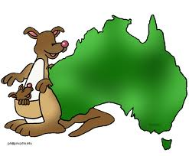<http://www.littlebirdtales.com/tales/view/story_id/224302>

Mrs. Davis’ students learned about Australia.

<http://www.littlebirdtales.com/tales/view/story_id/224260>

